Insertando imagen...

ACME-SF

G1.007

**Progress and analysis report D04**

20 May 2024

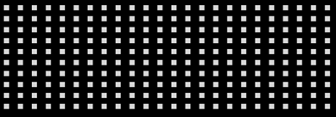

# Cover

|  |  |
| --- | --- |
| **Repository:** <https://github.com/Pablo-Caballero-Maria/Acme-One-24.1.0-C1.07> | |
| **Student #1**  **ID:** 31878881F  **UVUS:**  pabcabmar3  **Name:** Caballero María, Pablo **Roles:** manager, developer | **Student #2**  **ID Number:**49034820Q  **UVUS:** mararnmon  **Name:** Arnáiz Montero, Marco Antonio  **Roles:** developer, operator |
| **Student #3**  **ID Number:** 77865211E  **UVUS:**  alfalolan  **Name:** Alonso Lanzarán, Alfonso Luis  **Roles:** developer | **Student #4**  **ID Number:** 53932912M  **UVUS:** albsanmim  **Name:** Sánchez Mimbrero, Alberto  **Roles:** developer |
| **Student #5**  **ID Number:** 48123111G  **UVUS:** juagarcar4  **Name:** Garcia Carballo, Juan  **Roles:** developer, analyser, tester |  |

# Table of contents

Executive summary 3

Revision table 3

Introduction 3

Contents 3

Conclusions 6

Bibliography 6

# Executive summary

In this last deliverable, tests have been developed to verify that the application works correctly and is not vulnerable to serious errors. In addition, reports have been prepared for the analysis of the tests.

# Revision table

|  |  |  |
| --- | --- | --- |
| Number | Date | Description |
| 1.0 | 20/05/2024 | The document is created, and the planning is filled out. |
| 1.1 | 27/05/2024 | The progress is filled out and the document completed with his introduction and conclusion |

# Introduction

# This document represents the final progress and planning report for the ACME-SF project, pertaining to the "Design and Testing 2" course. In this phase, the project has made significant advancements in testing its architecture and key functionalities. Meticulous tests have been essential in ensuring an secure application with no mayor bugs or vulnerabilities, with a focus in the performace.

# Contents

* Planning­
  + Task assigned this delivery:

|  |  |  |  |
| --- | --- | --- | --- |
| **Title** | **Assignees** | **Estimate** | **Role** |
| Task S05-003/M: Produce an analysis report | JuanGarciaCarballo | 1 | Developer |
| Task S05-002/M: Produce a testing report. | JuanGarciaCarballo | 3 | Tester |
| Task S05-004/M: Produce a planning and progress report. | JuanGarciaCarballo | 1 | Developer |
| Task S05-001/T: Produce a test suite for Requirements #6 and #7. | JuanGarciaCarballo | 8 | Tester |
| Attend to classes | JuanGarciaCarballo | 14 | Developer |

* + Different moments in the delivery

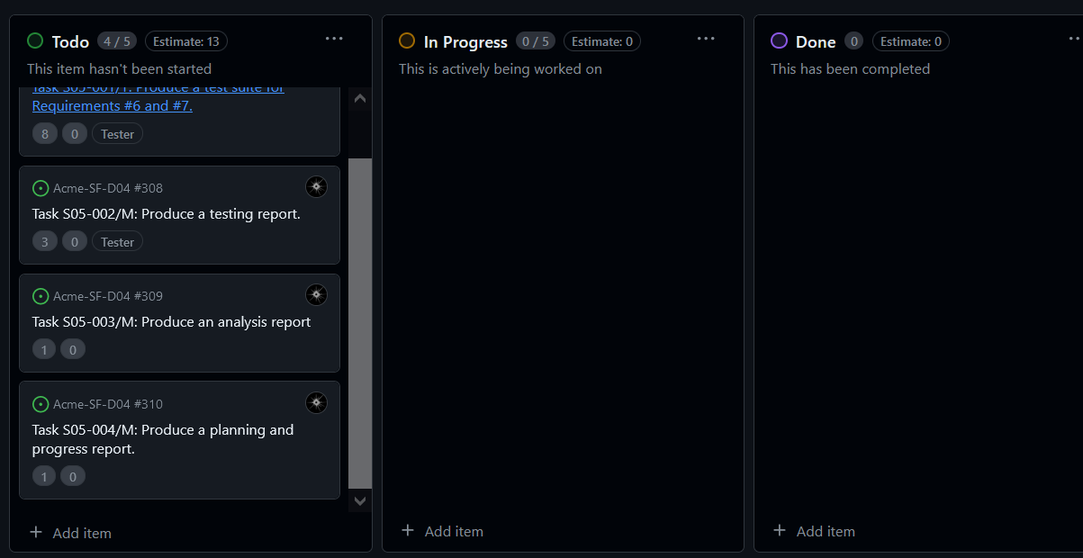

* + Budget

Cost of the tasks:

|  |  |  |  |  |
| --- | --- | --- | --- | --- |
| **Title** | **Estimate** | **Role** | **€ per task** | **budget of the task** |
| Task S05-003/M: Produce an analysis report | 1 | Developer | 20 | 20 |
| Task S05-002/M: Produce a testing report. | 3 | Tester | 20 | 60 |
| Task S05-004/M: Produce a planning and progress report. | 1 | Developer | 20 | 20 |
| Task S05-001/T: Produce a test suite for Requirements #6 and #7. | 8 | Tester | 20 | 160 |
| Attend to classes | 14 | Developer | 20 | 280 |
|  |  |  | TOTAL | 540 |

Total cost of the equipment: 1000€

Total: 1540€

With a lineal amortization in 3 years of 513,33 € per year.

* Progress
  + Progress Records

Juan Garcia Carballo Ratio:1, because he completed all the task assigned to him.

* + Conflicts

Intentionally blank

* + Real Cost

|  |  |  |  |  |
| --- | --- | --- | --- | --- |
| **Title** | **Invested time** | **Role** | **€ per task** | **budget of the task** |
| Task S05-003/M: Produce an analysis report | 1 | Developer | 20 | 20 |
| Task S05-002/M: Produce a testing report. | 4 | Tester | 20 | 80 |
| Task S05-004/M: Produce a planning and progress report. | 1 | Developer | 20 | 20 |
| Task S05-001/T: Produce a test suite for Requirements #6 and #7. | 9 | Tester | 20 | 180 |
| Attend to classes | 14 | Developer | 20 | 280 |
|  |  |  | TOTAL | 560 |

Total cost of the equipment: 1000€.

Total: 1560 €.

With a lineal amortization in 3 years of 520€ per year.

# Conclusions

The final delivery of the ACME-SF project has proven to be a notable success in terms of project execution and management. Despite the inherent challenges in implementing new functionalities, the team managed to keep costs aligned with the initial budget, with a total expenditure of €1,560 compared to an estimated budget of €1,540.

Which may seen bad, because the team exceeds the initial budget, but this increase is minuscule and should not be beyond what is expected in a project of this magnitude.

# Bibliography

Intentionally Blank